Application for Participation

All information requested on this application form will be kept confidential within the North Coast Small Business Development Center. Much of the personal and financial information collected in this application packet helps us advise you better and identify how to fund your participation in this program.
This is a three part process: Remember to also (1) (if you haven’t yet) sign up officially as a client at www.northcoastsbdc.org/apply and (2) complete your scholarship / income self-certification form.
Important: this program is made possible by a grant intended for entrepreneurs living at the low-to-moderate income level in Humboldt County. Applicants who are accepted into the program but don’t qualify for a scholarship may pay to attend workshops a la carte.
Please print or type legibly and give to SBDC staff member or email to flights@northcoastsbdc.org:
Your Name:
Your Business Name (if any):
Email Address:
Phone Number(s):
City/Town:

- Describe your business in detail. What is your product or service? Who is the best customer for it? How will the business earn money?

- Describe your biggest challenge to date with your business:

- Describe your most important accomplishment so far with your business:

- Check box if you already have / have done any of the following for your business:
  - Mentor (someone who you turn to for advice). Who?______________________________
  - Business Plan – completed date_____________
  - Financial Plan – completed date_____________
  - Marketing Plan – completed date_____________
  - Business License / Legal Incorporation
  - Loan from Bank or Other financial institution
  - Investment from individual, company, crowdfunding campaign or other
  - Marketing and advertising materials or online content
  - A bookkeeping system and/or bookkeeper/accountant. Specify: _____________________
  - Business Agent or Product Representative. Specify: _____________________
  - Samples, models, templates, or other concrete examples of your product or service
  - Revenue from selling the product or service totaling about $_________

- What business goals / needs / opportunities / challenges do you hope this program will help you accomplish in the next 6-12 months?
  - Mentor (someone who you turn to for advice). Who?______________________________
  - Business Plan – completed date_____________
  - Financial Plan – completed date_____________
  - Marketing Plan – completed date_____________
  - Business License / Legal Incorporation
  - Loan from Bank or Other financial institution
  - Investment from individual, company, crowdfunding campaign or other
  - Marketing and advertising materials or online content
  - A bookkeeping system and/or bookkeeper/accountant. Specify: _____________________
  - Business Agent or Product Representative. Specify: _____________________
  - Samples, models, templates, or other concrete examples of your product or service
  - Revenue from selling the product or service totaling about $_________
  - Other. Please describe:

- What SBDC services have you already accessed?
- Signed up for or started business consulting services
- Taken Business Basics or other workshops, if any? Which:
___Business Planning ___Financial Management ____Think Like a Marketer
Other:

- Number of hours per week you work:

On your business:_____ Another job or paid work:_____ School:_____ Other:_____

- Are there any other considerations you want to add?

Applicant Certification

My signature certifies:

- that all information provided on this application is accurate and complete to the best of my knowledge.

- that I am committing to participate fully in the entire program: attending all required sessions I can afford (barring emergencies), having regular one-to-one business consulting meetings, providing reports to SBDC of my progress, following through on the goals and homework I agree to with my business advisor.

Signature:__________________________________________ Date: ____________

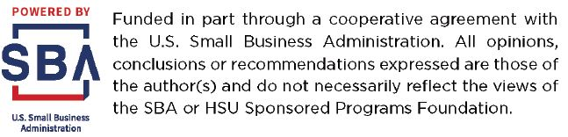 | 